**GUIDE FOR PIP INSTALLATION [WINDOWS 10]**

Guide for installing PIP in Python 3 :

1. Install Python 3 version
2. Install PIP3 , go to : <https://www.youtube.com/watch?v=mFqdeX1C-8M>
3. Go to <https://www.lfd.uci.edu/~gohlke/pythonlibs/#numpy> , download Numpy & Scipy according to your version .
4. Downloaded files copy & paste to Program Files/Python36/libs
5. Open CMD[Run as administrator]
6. pip3 install --upgrade pip
7. pip install --user scikit-learn
8. pip install numpy-1.12.0+mkl-cp36-cp36m-win32.whl
9. pip install scipy-0.18.1-cp36-cp36m-win32.whl
10. DONE

Guide for installing tweepy and TextBlob: [Install in CMD / PowerShell RUN AS ADMIN]

1. Pip install tweepy
2. Pip install TextBlob
3. Make sure u do not save any test.py or text.py files

Guide for Django

1. Must use run as admin[power shell]

**Guide for install PIP GraphViz**

1)Go to http://www.graphviz.org/Download_windows.php

2)Download the .msi files , NOT ZIP

3) Install python graphviz package , pip install graphviz in POWER SHELL [RUN AS ADMIN]

4)Go to My PC , right click Properties -> Advanced system -> Environment variables -> System Path [EDIT] -> User Path [EDIT] .

5)Paste the C:\Program Files (x86)\Graphviz2.38\bin to User Path

6) C:\Program Files (x86)\Graphviz2.38\bin\dot.exe to System Path

Guide for Django framework :

1)<https://simpleisbetterthancomplex.com/series/2017/09/04/a-complete-beginners-guide-to-django-part-1.html>

2) For windows : [Go to MyPC ->Properties -> Advanced Settings ->Environment Variables -> System Path & User path edit [copy paste the C:/Program Files/Python36/Scripts] , after that restart the CMD :D and follow the link ]

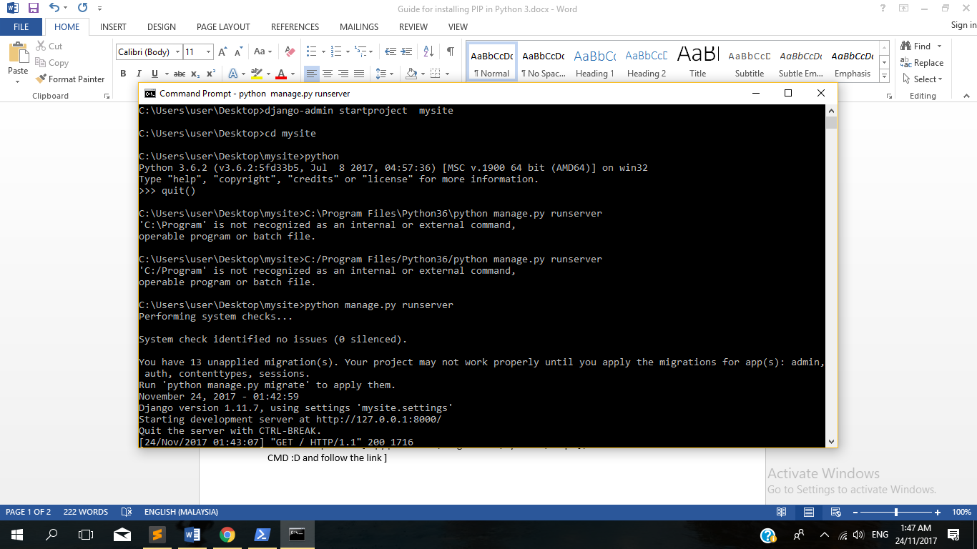

4)Then go to <http://127.0.0.1:8000/> :D Tada !

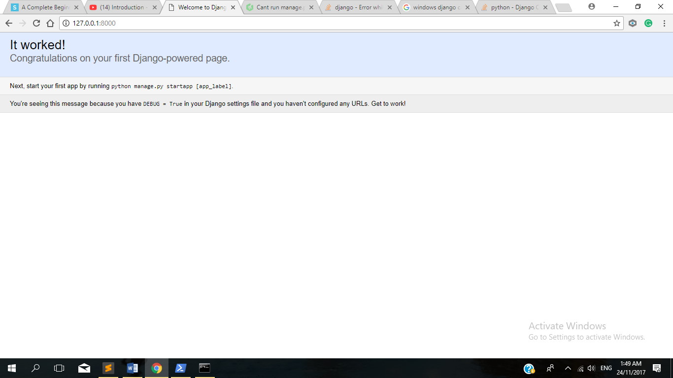

How to start coding in Django?[WINDOWs 10]

1. Go to Desktop -> MySite folder
2. -> Boards -> Views.py -> [ Paste the code from the website <https://simpleisbetterthancomplex.com/series/2017/09/04/a-complete-beginners-guide-to-django-part-1.html>]
3. Back to previous page -> mysite -> Url.py[MySite] [‘ ’]
4. Python manage.py run server